

April 16, 2019

Senator Ben Hueso

Chairman, Energy, Utilities, and Communications Committee

State Capitol, Room 4035

Sacramento, CA 95814

Re: Opposition to SB 386 (Caballero)

Dear Chairman Hueso,

The California Hydropower Reform Coalition strongly opposes SB 386 because it would undermine the intent of the Renewables Portfolio Standard (RPS) program to develop new renewable energy sources. SB 386 proposes RPS-eligibility for certain existing large hydropower facilities owned by a few irrigation districts. This reduces the need to develop new renewables and undermines the goal of the RPS program.

As you know, California recently took a strong step in addressing climate change by passing SB 100 which requires 100 percent carbon-free energy in California and includes large hydropower. We believe that SB 100 is the appropriate way to include large hydropower in California’s renewable energy supply without undermining the RPS program’s goals.

SB 386 is unfair. It creates a two-tiered system in which a select group of irrigation districts operate under one set of rules while all other power providers, including other irrigation districts, are held to a different standard. This disparity in treatment is unwarranted, especially in light of the off-ramps and remedies already enshrined in the RPS statute to assist ESPs with compliance. Allowing a special exception for one set of irrigation districts is bound to lead to additional similar requests for special treatment in the future.

In a broader perspective, the footprint of a hydropower project can be large with commensurate ecological harm. The inclusion of large hydro in the RPS would come just as power companies are determining that many hydropower projects are unsustainable and that even their grid regulating function may be subject to competition from more efficient technologies with a much smaller ecological footprint, such as batteries.

Changes similar to those proposed in SB 386 have been introduced every year for the last five or more, and each year it is defeated because of the reasons cited above. It is counterproductive to strengthen an important program one year and greatly weaken it soon after.

Again, for these reasons, we are opposed to SB 386.

Sincerely,

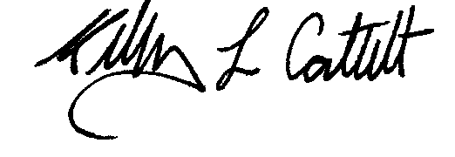

Kelly Catlett

California Hydropower Reform Coalition

**CHRC: 2340 Brisbane Street, West Sacramento, CA 95691; 916-995-9731**

**_____________________________________________________________________________________________**

**CHRC Steering Committee:**

**American Rivers, American Whitewater, California Outdoors, California Sportfishing Protection Alliance,**

**California Trout, Foothill Conservancy, Friends of the River, South Yuba River Citizens League,**

**Trout Unlimited, Water and Power Law Group**